

|  |
| --- |
| USER MANUAL |
|  |
| March 28  Saffron Application  Authored by: Tejasram Ramesh A046  Soham Nanavati A039  Avrati Motwani A038 |

# Preface

|  |
| --- |
| Subtitle Text Here With the onset of digital age all businesses must utilize digital arena to their advantage with the aim of improving customer experience and improving their utility value. This application is used by a restaurant to reach out to their customers, making their work easier by showing them the menu, price and letting them reserve a table at the joint. Furthermore it lets them choose a table of their choice, this increases customer satisfaction and loyalty.  This User Manual is there to guide all users on how to use this app. |
| The goal of our company is to have customer service that is not just the best but legendary. |
|  |

TABLE OF CONTENTS

1.

STARTING

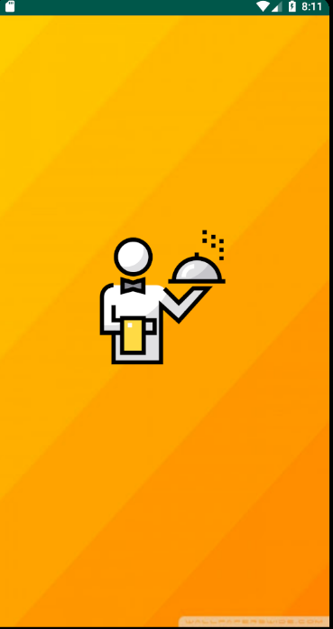

On starting the app the user is greeted by the splash screen

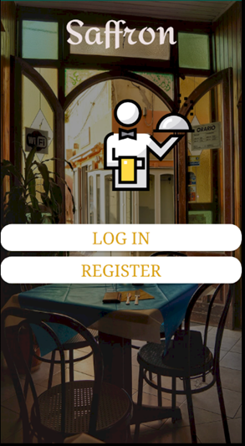Later the user can see the starting page. Where the user can either register if he has no account or Login to his account

REGISTER

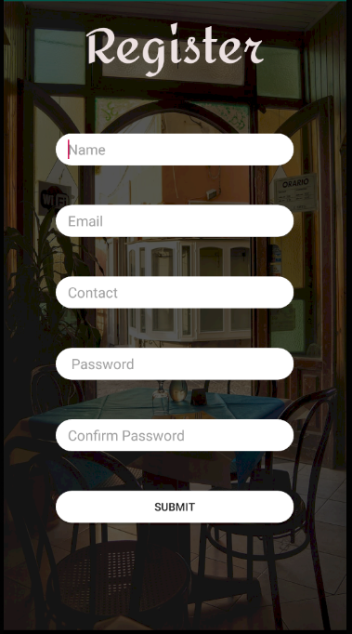On choosing register option. The user is taken to the registration page. The user must fill in the required details in order to make in an account.

On successful creation it will give the user a toast message saying “Account created successfully” and take you to the starting page.

LOGIN

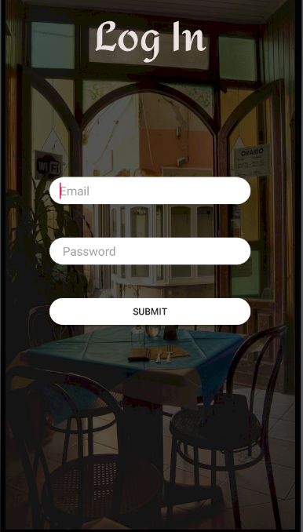

The user is prompted to enter the credentials of his account. This is the details the user has given during account creation.

On clicking submit button the user is taken to the Main page. Provided all the credentials provided are right.

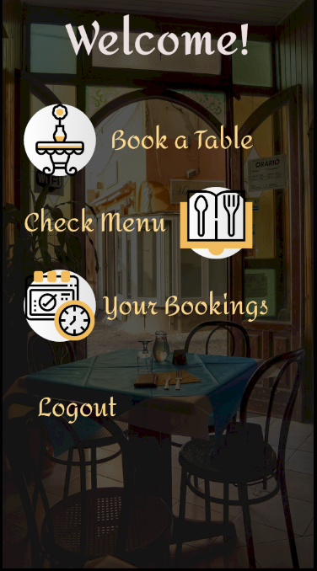MAIN PAGE

This is the main page of our application where the user can

1. Book a Table
2. Check the Menu
3. Booking a table : Choose the table preferred and the time of reservation
4. Logout

BOOK A TABLE

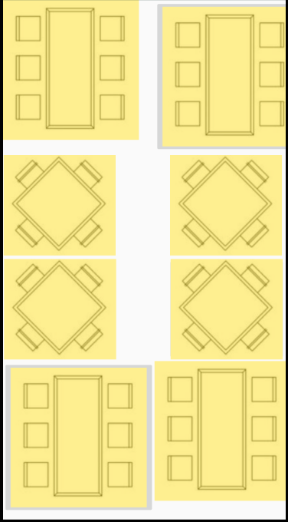On choosing Book a table the user is taken this Layout where the table options and positioning are shown. The user can further choose the table of his choice if its free else he will have to choose another table.

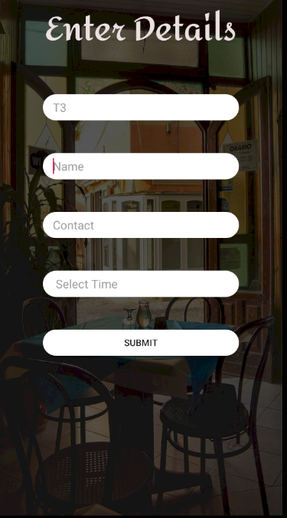The table unique id is shown at the top field. The user has to further fill in the details asked. Select time of his choice and then submit. On submitting user is taken to Main page.

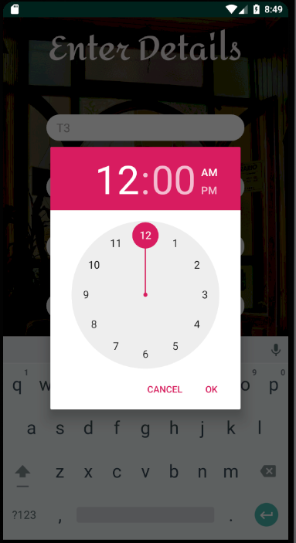

Menu page

The user has to choose “Check Menu” option to go to the menu page.

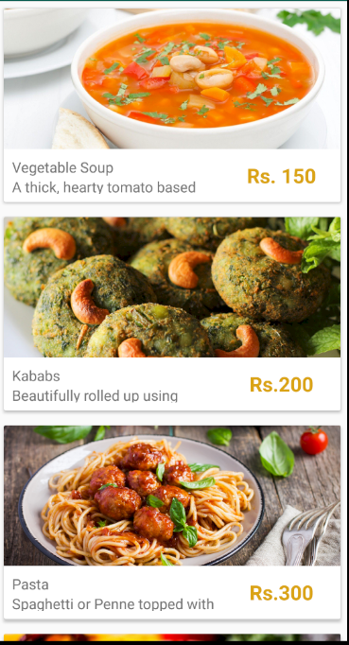The user is treated with the pictures of our Delicious Delicacies. The price and description is also given with the picture to see the complete description one must further choose the dish.

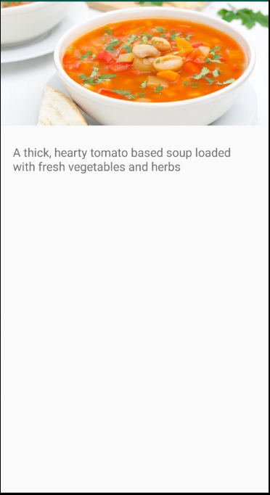This is the page with the complete description of the dish. This page opens only when the user chooses the dish.

YOUR BOOKINGS

The user can check all of his bookings by choosing the “Your Bookings” option in the Main page.

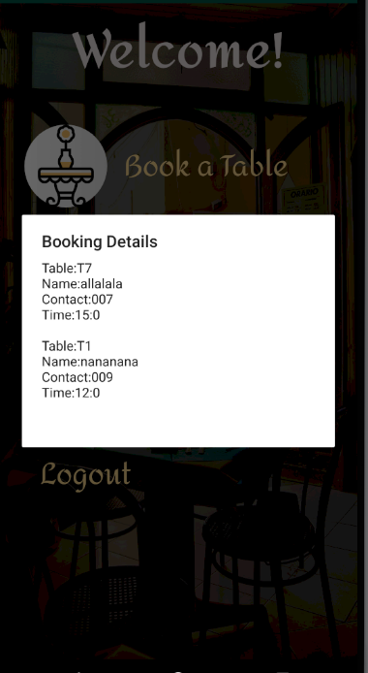 This is the entire booking history of the user with the latest one on top.

LOGOUT

To logout of the app the user must choose “Logout” option. This will take the user to the starting page.

After clicking Logout :

FUNCTIONALITIES UNDER DEVELOPMENT

We strive to improve our user experience and can’t wait to tell you about our plans for the app!!

1. We intend to take this app on the cloud and provide direct synchronization with the Calendar app on Android and IOS.
2. Enabling “Directions” Feature to help user find his way to our restaurant using google maps.
3. We further want to introduce delivery option with various payment modes. It will also have a live tracking feature that will help the user track the delivery boy, time of food preparation and the chefs name.